 | The CAMECA IMS 7f (*)  ion optics user’s guide (1)  The primary ion optics  00 45 610 681 - Type 108 – Indice A
0000.doc
(*)This documentation is relevant for the IMS7f the number of which is equal or larger than 715)
Index
Contents

1. Introduction 3
1.1 The IMS 7f 3
1.2 Expert user/ operator 3
1.3 Basic ion optics : Lenses, deflectors, stigmators... 3
1.4 Other documentation 3
2. The primary column 4
2.1 Overview 4
2.1.1 Description 4
2.1.2 The different primary column operating modes 7
2.2 The primary column physical principles 7
2.2.1 The Primary Beam Mass Filter (PBMF) 7
2.2.2 Operating the primary column in the Gaussian Beam mode 8
2.2.2.1 Principles 8
2.2.2.2 The aberration issue 8
2.2.2.3 Making a primary spot of a given size 9
2.2.3 Operating the primary column in the Shaped Beam mode 10
2.2.3.1 Principle 10
2.2.3.2 Making a primary spot of a given size with the Shaped Beam mode 11
2.2.4 Rastering the primary beam Erreur ! Signet non défini.
2.2.5 Primary beam impact angle and the landing issue 14
2.3 Tuning the primary ion column 18
2.3.1 Overview Erreur ! Signet non défini.
2.3.2 Overall alignment (expert level) Erreur ! Signet non défini.
2.3.3 Regular alignment (Operator level) Erreur ! Signet non défini.
3. The Secondary ion optics (*) 21
4. The secondary ion detectors (*) 21
5. The Depth profiling issue 21
6. Controlling the ion optics from the computer 21

Contents ↑

Introduction

The IMS 7f
The Cameca 7f are magnetic sector SIMS Instruments. The IMS-7f ion optics consist of
- A primary column, equipped with 2 sources, presented in this volume, Primary column, ion optics user’s guide
- The secondary ion optics, presented in the second ion optics user's guide.

Additionally to the ion optics user's guide 2 volumes, all the IMS 7f and user's guide volumes are available from the Index.

Expert user/ operator
The largest part of this document is targeted to give an expert user a deep understanding of the instrument. Only some parts, labelled “ operator level ” are suited to the user who would just like to run routine analyses or analysis batches.

Basic ion optics : Lenses, deflectors, stigmators...
In ion optics, or more generally in charged particle optics, image transfer may be described with the same formalism as for conventional photon geometrical optics. The paraxial theory and the matrix method can be used in the same way for defining first order properties such as focal length for a lens or second or third order aberrations. The same terminology (ray, conjugated points, principal plane, spherical aberration, stigmatism etc...) is used for both ion optics and photon optics. It is therefore possible to read and to understand coarsely this ion optics user's guide (§ the primary column and § the secondary ion optics ) without special knowledge in matter of ion optics. For a more accurate understanding, it might be necessary to read the Basic ion optics user's manual which contains a short presentation of the ion optical devices (Lenses, Deflectors, Stigmators, ESA, Magnets...) implemented in the Cameca SIMS instruments.

Other documentation
Complement to the ion optics user's gide
- The Cameca IMS 7f ion source user’s guide, for both the Cesium source and the duoplasmatron.
- The NEG user's guide for the Normal incidence Electron Gun (NEG).
- The secondary ion optics user's guide

Related documentation
- CAMECA IMS basic physical principles
- The Tuning software user's guide for controlling the instrument from the computer.
- The Tools software user's guide, for setting up some special devices (EM, FC…)
- The Vacuum user's guide
Contents ↑

The primary column

Overview

Description
The primary ion optics consists of two ion sources, a magnetic sector and a set of electrostatic optical devices purposed for focusing and deflecting the ion beam.

The ion sources are:

q a duoplasmatron with a cold cathode capable of producing positive or negative ions;
q a thermo-ionization source producing Cs+ ions.

See The Cameca IMS 7f ion source user’s guide
Contents ↑

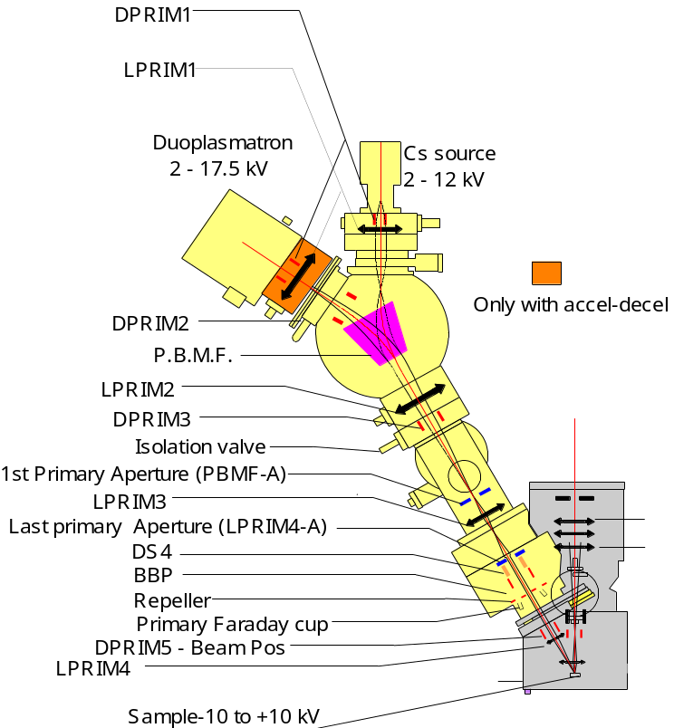

Contents ↑

Device Label | Tuning Labels | Functionality
Cs Source | ACCEL HV  IONIZER  RESERVOIR | Cameca microbeam cesium source (refer to the ion source user'guide § The Microbeam Cs Source ) ,  ACCEL HV is the ionizer High Voltage with respect to the ground.  IONIZER is the electron current between the ionizer filament and the ionizer.  RESERVOIR is the electron current between the reservoir filament and the reservoir
Duo Source | ACCEL HV  ARC  COIL | Cameca Duoplasmatron source (refer to the ion source user'guide § The Duoplasmatron Source)  ACCEL HV is the source High Voltage with respect to the ground.  ARC is the plasma arc current.  COIL is the duoplasmatron coil current.
Primary Beam Mass Filter | PBMF | Switching electromagnet for selecting either the Cs axis or the Duo axis, according to the electromagnet current. This so-called magnet has also focusing stigmatic properties and transfers the source image.
DPRIM1 | DPRIM1-X,  DPRIM1-Y | A 4 plate deflector used to center the beam within the LPRIM1 lens.
LPRIM1  LPRIM1-d | LPRIM1 | An electrostatic lens purposed for making approximatively the image of the source at scale –1:1 upstream the PBMF.  LPRIM1 is implemented in the Cs side and LPRIM1-d in the duoplasmatron side.
DPRIM2 | DPRIM2-X,  DPRIM2-Y  D2-S1 | A 4 plate deflector used to center the beam within the LPRIM2 lens.  D2-S1 is an XY stigmator function. It may be applied onto the DPRIM2 plates to optimize the circularity of the source image.
LPRIM2 | LPRIM2 | An electrostatic lens purposed for making a source image approximatively at the Mass aperture plane.
DPRIM3 | DPRIM3-X,  DPRIM3-Y | A 4 plate deflector used to re-center the beam.
1st Primary Aperture | PBMF-A | Set of 4 apertures of different diameters (3mm, 400µm, 200µm, 100µm) mainly purposed for filtering in mass the primary ion beam.
LPRIM3 | LPRIM3 | An electrostatic lens purposed for tuning the source demagnification in the gaussian beam mode.
Last Primary Aperture | LPRIM4-A | Set of for apertures (750µm, 400µm, 200µm, 100µm) purposed for limiting the ion beam angle aperture, so far the primary column is working with the so-called gaussian mode.  (see the last stage figure)
DS4 | D4 X  D4 Y  DS4-S1  DS4-S2 | An octopole for achieving both astigmatism correction functions, respectively in XY (s1 stigmatism) and at 45° (s2 stigmatism)  (see the last stage figure)
BBP | BBP def | A pair of deflection plates purposed for blanking the beam into the FCp primary Faraday cup, either in a continuous mode or in a sampling mode. (see the last stage figure)
Primary Faraday Cup | FCP  FCP REP | Primary Faraday Cup  The repeller (FCP Rep) is a plate, perpendicular to the beam axis, located just upstream FCp and purposed for repelling the secondary electrons. (see the last stage figure)
DPRIM5 | Beam Pos-X  Beam Pos-Y  Raster Y&Y  D5 S1 | A 4 plate deflector with a set of implemented functions:  - Primary beam X&Y position (Beam Pos)  - Primary beam rastering system (Raster)  - XY stigmator (D5-s1)  (see the last stage figure)
LPRIM5 | LPRIM5 | Last lens used for achieving the primary spot focusing.  (see the last stage figure)

Contents ↑

The different primary column operating modes
The IMS7f primary column can be operated in two modes : Gaussian Beam and Shaped Beam.
Gaussian Beam mode consists of forming a reduced image of the source onto the sample, the reduction being achieved in several stages with the help of the electrostatic lenses.
Shaped Beam mode consists of using the first lens for illuminating a so-called stencil, i.e. an aperture and to use the last lens for producing an image of this aperture onto the sample.
The choice between the two modes will depend on the application: the gaussian mode will be preferred whenever the primary spot is required to be smaller than 10 µm while the shaped beam will be prefered whenever the spot is required to be fixed constant during an analysis.

The primary column physical principles

The Primary Beam Mass Filter (PBMF)

The primary beam mass filter is a symmetrical magnetic prism making possible to implement two different ion sources on the same instrument. Both the polarity and the intensity of the magnetic field can be switched so as to deflect the ions originating from one source or the other.
Magnetic Sector features  Under the influence of a uniform magnetic field B, ions with charge n and mass M, accelerated by potential V, follow a circular path through a magnetic prism with a radius:  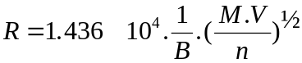  Due to the angle between the magnet faces and the beam axis, the magnet has focusing properties. It is equivalent to the arrangement [83mm space, 1450mm focal length lens, 83 mm space] | 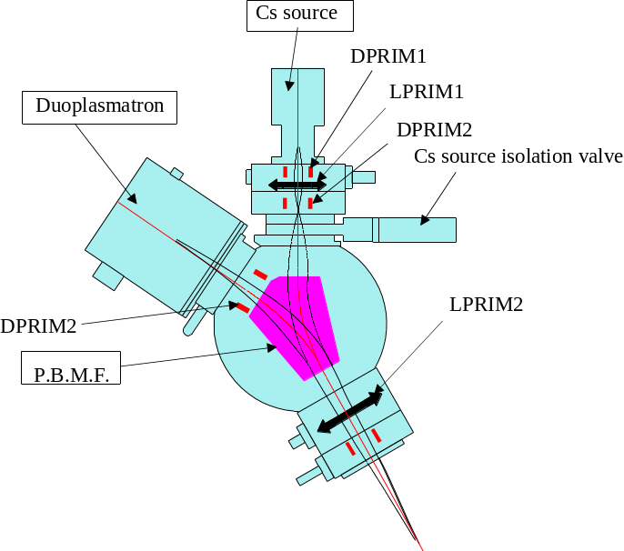

The LPRIM1 lens is purposed to make a Cs source image at approximatively the same distance of the magnet as the Duoplasmatron source. Due to its focusing properties, the PBMF in cooperation with the LPRIM2 lens produces a second source image close to the Mass Aperture plane.

Contents ↑

Operating the primary column in the Gaussian Beam mode

Principles

The extraction electrode of both sources is connected to the ground potential of the instrument, while the duoplasmatron and Cesium gun assembly (ionizer + reservoir) are brought at high voltage. According to the polarity, the positive or negative produced ions are accelerated. This optical system (extraction electrode + source assembly) forms a source cross-over with a diameter of about 500 μm and 50 μm for the duoplasmatron and Cs sources, respectively. The image of this cross-over is focused on the sample surface thanks to different optical systems of the primary column: LPRIM1, LPRIM2, LPRIM3 and LPRIM4 associated to deflectors (DPRIM) and apertures (A).

As the diameter of the primary spot on the sample surface is variable from 0.2 to 200 μm, the reduction of the system should be adjustable between 0.4 and 2500. The more the central electrode of the electrostatic lenses LPRIM1, LPRIM2, and LPRIM3 will be strongly polarized, the shorter the focal length and the smaller the diameter of the spot will be. The lens LPRIM4 is used to focus the beam on the sample surface.

For the duoplasmatron, the position of the source cross-over at the entrance of the magnetic sector is mechanically fixed, while for the Cs source, the image of the source cross-over given by the lens LPRIM1 acts as a source point for the magnetic sector. Its position is therefore adjustable as a function of LPRIM1 voltage. For the Cs beam, the excitation of LPRIM1 will be adjustable to optimize the Cs beam density for different ranges of spot sizes.
Contents ↑

The aberration issue

The spot size at the sample plane results from the reduction of the source achieved by the successive lenses LPRIM1, LPRIM2, LPRIM3 and LPRIM4, but it depends also on the aberrations produced mainly by the last lens LPRIM4.
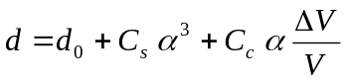

Where d₀ is the diameter of the reduced image of the source, α is the beam half-aperture angle at the sample plane, C_{s} is the spherical aberration (≈1500mm) , C_{c} is the chromatic aberration (≈100 mm), ΔV/V the relative energy dispersion of the ions (typ 1/1000 for the Duoplasmatron 0₂⁺ ions, and 1/4000 for the Cs⁺ ions).

The beam half-aperture angle is determined by both the diameter of the so-called Primary Beam Aperture and the exact location of the source image formed by LPRIM3 which may vary according to the LPRIM3 setting.

Example
- Distance between the source image formed by LPRIM3 and the limiting aperture (PBA) : 150 mm (typical)
- Distance PBA-LPRIM4: 150 mm
- Distance LPRIM4-Sample: 40 mm
- Primary Beam Aperture diameter: 200µm

This leads to a beam diameter of 400 µm in the LPRIM4 plane and α = 0.2/40 = 0.005

In the case of Cs⁺ ions (ΔV/V=1/4000)
C_{s} α³=0.18 µm
C_{c} α (ΔV/V) = 0.12 µm

These results must be considered as orders of magnitude. The example illustrates why it is necessary to use an aperture smaller than 400 µm for achieving small spots.
Contents ↑

Making a primary spot of a given size

Primary ion=Cs⁺, Acceleration Voltage=+10 KV, Sample HV=-5KV
Spot diam (µm) | 100 | 18 | 1
Apert diam (µm) | 750 | 750 | 200
I(nA) | 600 | 100 | 0.05
LPRIM1 (V) | 9240 | 9500 | 9500
LPRIM2 (V) | 6960 | 6410 | 7690
LPRIM3 (V) | 4670 | 5700 | 9500
LPRIM4 (V) | 6980 | 6870 | 6900

Primary ion=O₂⁺, Acceleration Voltage=15 KV, Sample HV=+5KV
Without the Accel-Decel or LPRIM1-d option
Spot diam (µm) | 150 | 18 | 1
Apert diam (µm) | 750 | 750 | 200
I(nA) | 3000 | 200 | 0.05
LPRIM1 (V) | - | - | -
LPRIM2 (V) | 8400 | 8400 | 8600
LPRIM3 (V) | 6200 | 7400 | 12400
LPRIM4 (V) | 10200 | 10200 | 10200

With the Accel-Decel or LPRIM1-d option
Spot diam (µm) | 100 | 18 | 1
Apert diam (µm) | 750 | 750 | 200
I(nA) | 1000 | 200 | 0.1
LPRIM1 (V) | 12200 | 12200 | 12200
LPRIM2 (V) | 7900 | 7900 | 7900
LPRIM3 (V) | 6600 | 7.39 | 11400
LPRIM4 (V) | 10200 | 10200 | 10200

Primary ion=O⁻, Acceleration Voltage=-13 KV, Sample HV=+10KV
Spot diam (µm) | 150 | 12 | 1
Apert diam (µm) | 750 | 400 | 100
LPRIM1-d (V) | 8520 | 10883 | 10883
LPRIM2 (V) | 7140 | 7140 | 8350
LPRIM3 (V) | 6245 | 10176 | 11930
LPRIM4 (V) | 8819 | 8682 | 8732

Contents ↑

Operating the primary column in the Shaped Beam mode

Principle
In this mode the lens LPRIM2 of the primary column (LPRIM3 is not used) is tuned in order to illuminate the Primary Beam Aperture (PBA) with a beam with a rather homogeneous density. The Lens LPRIM4 is used to focus a de-magnified image of the Primary Beam Aperture. The same principle can be used to focus onto the sample an image of the Mass Aperture (MA)instead of the Primary Beam Aperture.

In such an optical arrangement, the beam intensity is adjusted by changing the LPRIM2 voltage. Contrary to the Gaussian Beam mode, LPRIM4 voltage remains constant whatever the LPRIM2 voltage is.

Shaped beam mode :
(the lens values in bits are just indicative)
In the Shaped Beam mode, primary beams with a sharp contour and an uniform beam density can be focused onto the sample surface but at the expense of the beam density. Very high sputter rates cannot be achieved but a shaped beam can be used to run analyses with a static primary beam while keeping good crater bottom flatness. However, it must be emphasized that the best crater quality is obtained by rastering the primary beam.

Note that in the Shaped Beam mode, sputtered craters with a static beam have an elliptical shape because of the oblique incidence of the primary beam. This is partially corrected by the use of the D5-s1 function.

Generally speaking, the shaped beam mode will be preferred when analysis are run with a static primary beam (isotopic ratio measurements, imaging in microscope mode). The critical illumination mode will be preferred when a rastered and/or small focused beam is required (profiling with high depth resolution, species mapping with high lateral resolution).
Contents ↑

Making a primary spot of a given size with the Shaped Beam mode
When imaging the Mass Aperture, the reduction is 1:10, and when imaging the Primary Beam Aperture, the reduction is 1:3.5
Imaging the Mass aperture is more advantageous for the aperture lifetime: Since the ion density is lower at the aperture plane the aperture sputter rate is therefore reduced.

Proj1 is the mode involving the projection of the 1st primary aperture (PBMF-A)
Proj2 is the mode involving the projection of the last primary aperture (LPRIM4-A)

With the LPRIM1-duo option
(Source= Duoplamatron, O⁻ Source HV=-13 kV)
Mode | 1st Apert  (PBMF-A)  (µm) | Last apert  (LPRIM4-A)  (µm) | LPRIM1  (Volts) | LPRIM2  (Volts) | LPRIM3  (Volts) | LPRIM4  (Volts) | Spot  Diameter  (µm)
Proj2 (LPRIM4 | 3000 | 100 | 5700 | 5110 | 0 | 9260 | 27
Proj2 (LPRIM4 | 3000 | 50 | 5700 | 5110 | 0 | 9260 | 15
Proj1 (PBMF-A) | 200 | 750 | 10250 | 7050 | 0 | 8800 | 20
Proj1 (PBMF-A) | 100 | 750 | 10250 | 7050 | 0 | 8800 | 10

Without the LPRIM1-duo option
(Source= Duoplamatron, O⁻ Source HV=-13 kV)
Mode | 1st Apert  (PBMF-A)  (µm) | Last apert  (LPRIM4-A)  (µm) | LPRIM2  (Volts) | LPRIM3  (Volts) | LPRIM4  (Volts) | Spot  Diameter  (µm)
Proj2 (LPRIM4 | 3000 | 100 | 6350 | 0 | 9260 | 27
Proj2 (LPRIM4 | 3000 | 50 | 6350 | 0 | 9260 | 15
Proj1 (PBMF-A) | 200 | 750 | 7550 | 0 | 8800 | 20
Proj1 (PBMF-A) | 100 | 750 | 7550 | 0 | 8800 | 10

(Source= Cs+, Source HV=10 kV)
Mode | 1st Apert  (PBMF-A)  (µm) | Last apert  (LPRIM4-A)  (µm) | LPRIM1  (Volts) | LPRIM2  (Volts) | LPRIM3  (Volts) | LPRIM4  (Volts) | Spot  Diameter  (µm)
Proj2 (LPRIM4 | 3000 | 100 | 7570 | 5550 | 0 | 9260 | 27
Proj2 (LPRIM4 | 3000 | 50 | 7570 | 5550 | 0 | 9260 | 15
Proj1 (PBMF-A) | 200 | 750 | 7570 | 6500 | 0 | 8800 | 20
Proj1 (PBMF-A) | 100 | 750 | 7570 | 6500 | 0 | 8800 | 10

Contents ↑

The IMS7f primary column last stage

Overview

Primary Column last stage
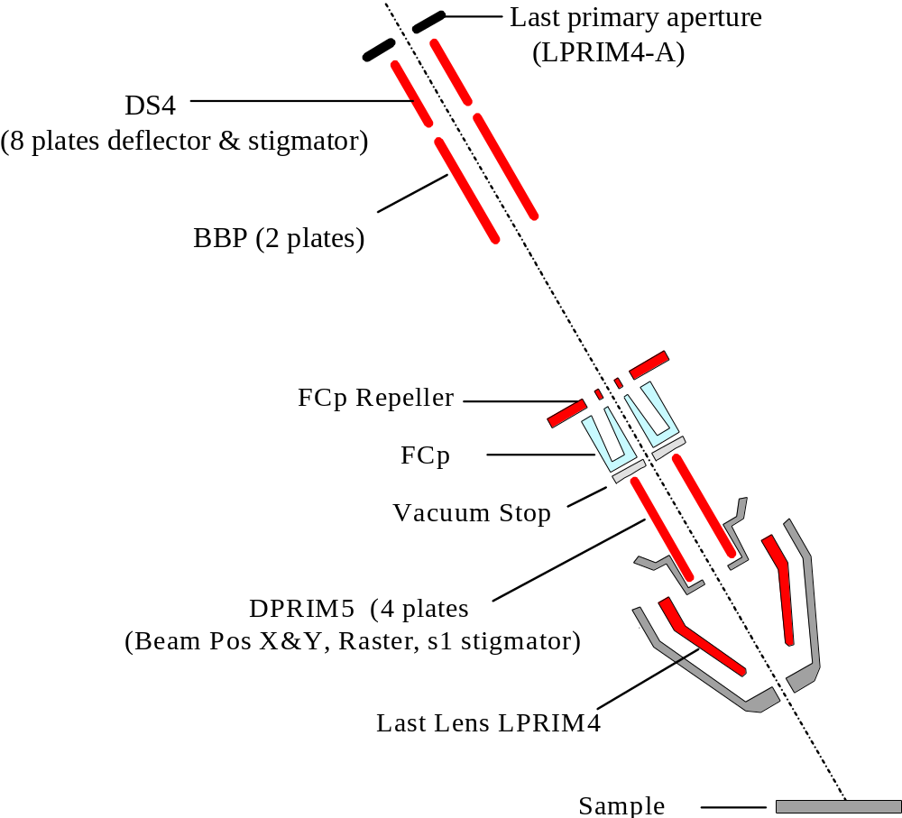

Rastering the primary beam and Monitoring the primary beam current
The ion primary beam can be rastered within the sample plane in order to achieve a scanning ion image or to record a depth profile with a flat bottom crater (See in the secondary ion optics user's guide the section § the depth profiling issue). A sequencer generates continuously Raster X&Y saw teeth which are applied onto the DPRIM5 plates when the Raster/Static selection is set to Raster. The 80 ms frame consists of 1024 lines rastered along the X-axis.
As it can be read in the following section § Rastering the primary beam, A sequencer generates continuously Raster X&Y saw teeth which are applied onto the DPRIM5 plates when the Raster/Static selection is set to Raster. The 80 ms frame consists of 1024 lines rastered along the X-axis.
Monitoring continuously the primary current is achieved in a sampling mode : Within every frame, a given percentage of the lines is dedicated to the current measurement. In the hereafter figure, this percentage is 2%. During 10 lines at the beginning and 10 lines at the end of the frame, the beam is blanked off the axis, into the primary Faraday cup. As a fast response is not required, the Faraday current is measured with a low bandwith and multiplied by the inverse of the sampling percentage for giving back the actual primary current. The unavoidable counterpart of this measurement is that the primary beam is not working during the 2% measurement time.

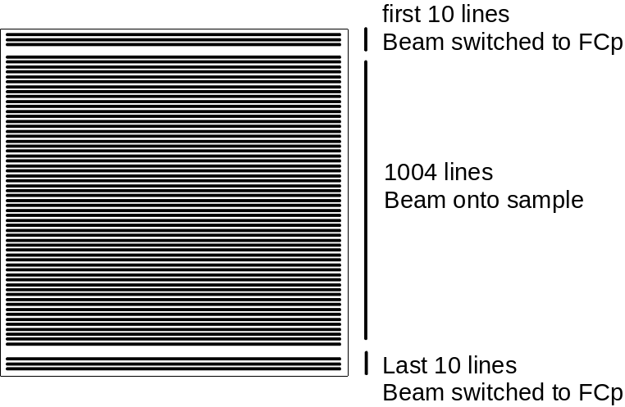

Practically, the recommended sampling rate is 10%. It corresponds to Sampl_FC=461 (Refer to Tuning/Synoptics/Lprim4)
Contents ↑

Using the FCp Sampling mode for centering the beam in the primary last lens

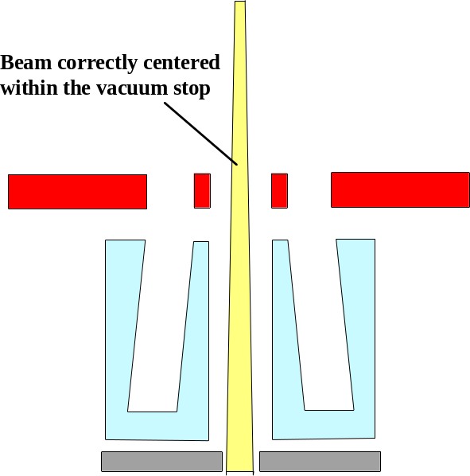 | 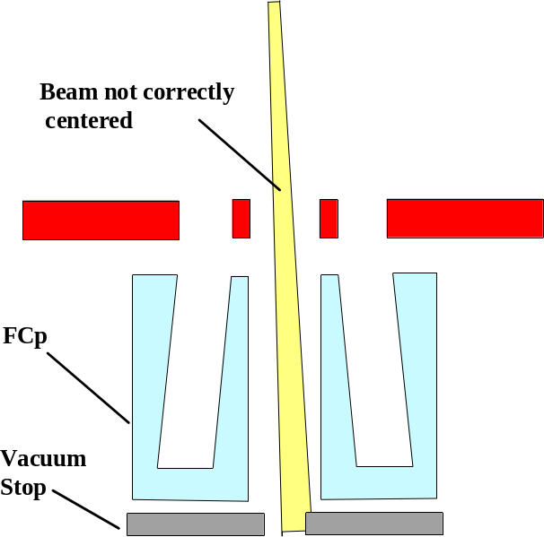

When the Beam is ON, but not correctly aligned, so that it strikes the vacuum sample, backscattered ions and secondary electrons (electrons are dominating) impinge the FCp Faraday cup, and in the case of Ipr Sampling ON, this spurious signal is amplified by the inverse of the sampling rate. It results that the read current in the sampling mode is biased and its displayed value is not the same as the value displayed with Beam OFF. This is a very convenient criterion for aligning the beam in the vacuum stop and further in the LPRIM4 lens.
With positive primary ions, spurious signal is negative when the beam strikes the stop, Beam ON sampled and computed current is smaller than the actually deflected Beam OFF current.

With negative primary ions, spurious signal is also negative when the beam strikes the stop, Beam ON sampled and computed current is therefore larger than the actually deflected Beam OFF current.

D4 X&Y must be tuned so that the Beam ON displayed current has the same value as the Beam ON current

Contents ↑

Primary beam impact angle and the landing issue
All the space located between the source and the extraction electrode is at the ground potential except the space located between the extraction electrode and the sample plane. This space is an accelerating region for the secondary ions, while, for the primary ions, it is a decelerating space if both the primary and secondary voltage have the same polarity and it is an accelerating space if they have opposite polarities. As the primary axis is not normal to the sample plane, the primary trajectory is curved in this region, and it would not impinge the sample plane onto the secondary axis if there was not a compensating deflection depending on the decelerating or accelerating field.

This compensating deflection is achieved with the double stage deflector DPRIM4-X (also labelled as Beam Pos-X). The center of this deflection is located at the last lens plane. The next figure, standing for positive primary ions (+10 kV), displays both cases:  - Sample HV=9 kV : The final space is decelerating.  - Sample HV=-9 kV: The final space is accelerating  In both cases, a deflection must be applied before the last lens (LPRIM4) in order to force the primary trajectory to impinge the sample plane onto the secondary axis. | 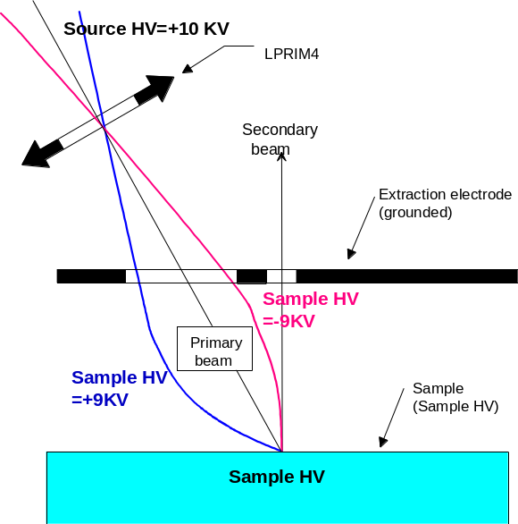

The primary beam impact angle can be computed, in first approximation, from the relationship
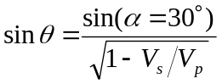
Where V_{s} and V_{p} stand respectively for the secondary and the primary acceleration voltage.
It must be noticed that the primary column DPRIM4 double deflector used to bring the primary spot back to the secondary axis, makes the primary beam entering the secondary ion extraction space with an angle α' different from the primary axis angle α=30° (refer to the next figure). A more accurate computation of the impact angle values can be performed by taking into account this effect. θ and θ' for different V_{s} and V_{p} are reported in the hereunder table
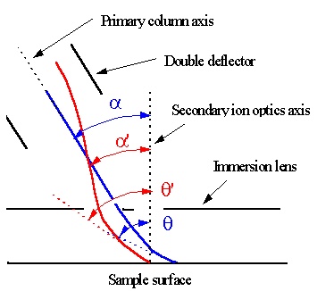 | 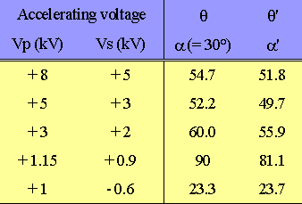

The diagram plotted in the hereunder figure displays the dependance of θ' on the primary acceleration voltage V_{p} for different secondary extraction voltage V_{s}.
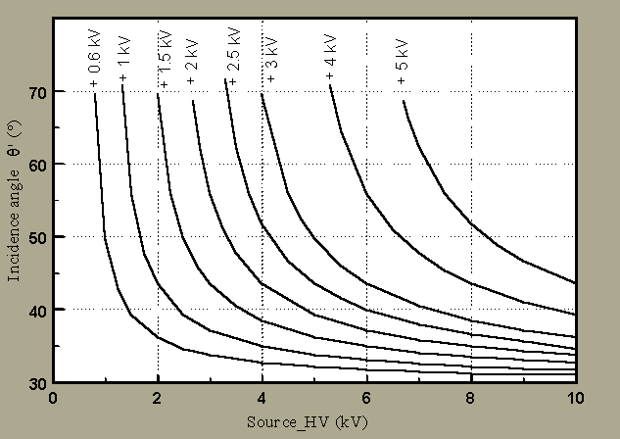

Examples of primary and secondary acceleration voltages suited to adjust the impact angle for impact energies of 2 kev, 1 keV and 0.5keV. | 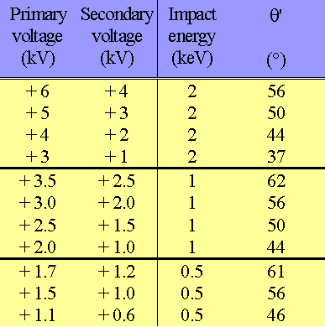

Contents ↑

Tuning the primary ion column

Overview
The primary preset pad
In the software tuning user's guide, it is explained that for the same MAP (Main Analytical Parameters), several preset can be recorded, corresponding to primary probes of different sizes and different ion current intensities. Up to 9 different primary presets can be saved in the same ISF (Instrument Status File). One given preset can be recalled by clicking the corresponding button on the primary preset pad. Each of these presets consists of a set of the following parameters:
- The 4 lenses (LPRIM1, LPRIM2, LPRIM3, LPRIM4)
- DPRIM3 X&Y
- D4 X&Y
- Beam Pos X&Y
- DS4 s1&S2, D5 S1

While the other parameters (DPRIM1 X&Y, DPRIM2 X&Y, PBMF, Def_FC, and the aperture mechanical centering) are identical for all presets of the same ISF.

The mechanical apertures are expected to be centered once only in the instrument life.
This centering is not critical

Overall alignment and regular alignment.
The overall alignment must be achieved by the expert user whenever the primary column has been opened for cleaning. It can also be achieved if the ISF is deleted or if the expert user wants to check the primary presets of a given ISF or to build a new ISF.

The regular alignment is what is expected from a simple operator after the loading of an existing ISF.

Contents ↑

Overall alignment (expert level)
STARTING CONDITIONS:
It is assumed that the secondary optics was aligned previously so that it is possible to display a nice sample image with the MCP (Micro Channel Plate, Refer to the secondary ion optics guide).
Recommended samples: Ta/Si Grid (M=Si) for Cs+ and O2+, Cu/Al Grid (M=Al) for O- and O2-

Secondary ion optics:
- Transfer lens ⎯ 200 µm, FA = 8000µm image mode, CA#2 (150 µm) centered for a rather good quality of the image. Adjust fine controls of the immersion and transfer lenses to get the best image.
- Raster=0 . The primary spot is coarsely centered in the FA.
- Select the largest PBMF Aperture #1 (3000µm) and the largest Primary Beam Aperture #1 (750µm).
- Primary beam OFF: intensity measured in the Faraday cup.

STEP A: Getting the maximum primary current
1. Set the LPRIM1 Lens at 8500 Volts in theCs+ case (Source HV=+10 kV) and at 8520 Volts in the O- case (Source HV=-13 kV). Both apertures, PBMF-A and LPRIM4-A, are set at the position corresponding to the maximum diameter. Check that the BBP deflection (DEF FC, Refer to Tuning/Synoptics/Lprim4) is at its regular value (1502 digits, i.e. +/- 150 volts for Source HV=13 kV)

2. Maximize intensity by adjusting one-by-one:
- Faraday cup deflection voltage;
- PBMF;
- LPRIM2 and LPRIM3 voltages;
- DPRIM1, DPRIM2, DPRIM3, D4 voltages (deflection effects should remain as close as possible to 0);
- Center both apertures (PBMF-A and LPRIM4-A);

3. Try to get all the deflectors DPRIM1 X&Y, DPRIM2 X&Y, DPRIM3 X&Y, as close as possible to zero while keeping a spot image, and maximize again the primary intensity (See above 1.)

4. Check that regular maximum currents are obtained:
5.0 µA for +12 kV (O2+)
0.5 µA for -12 kV (O-)
0.5 µA for +10 kV (Cs+)

If it is not the case, tune the source parameters according to the ion source user’s guide .

5. Save the settings in the top right position of the primary preset pad and label it Max.
Contents ↑

STEP B Getting a medium spot
- recall the Max preset.
- Beam ON
- Ajust Beam Pos X&Y for getting some signal on the MCP plane.
- Set The set of 4 lenses to their regular values (refer to the section § Gaussian spot size) for a medium spot (30 to 10 µm) while keeping the spot. Focus coarsely the spot with LPRIM4.
- Beam OFF, Maximize the primary beam current with DPRIM3 X&Y.
- Set Ipr Sampling ON, with a sampling rate of 10% (Refer to the section § Monitoring the primary ion beam current) i.e. in Tuning/synoptics, Sampling rate=461.
- Beam On. Tune D4 X&Y according to the section § Using the FCp sampling mode.
- Tune DPRIM1 X&Y so that when varying LPRIM1, the displayed primary spot does not shift.
- Tune DPRIM2 X&Y so that when varying LPRIM2, the displayed primary spot does not shift.
- Tune the mechanical centering of the last aperture DPRIM4-A so that when varying LPRIM3, the displayed primary spot does not shift.
- Beam OFF, Maximize the primary beam current with DPRIM3 X&Y.
- Switch the first primary aperture PBMF_A to position 3 and center X&Y finely for maximizing the current. Switch back PBMF_A to its largest poistion.
- Store the preset in the position "3" of the primary preset pad, with the label corresponding to the ion beam current in nA.

Contents ↑

STEP C Building a customized preset.

- Select the closest preset to the targeted preset and copy it in a new preset.
- Give a suitable label to the new preset.
- Change the apertures PBMF_A or LPRIM4_A if required. For example, if you build a 5µm preset from a 1 µm preset, it is recommended to switch the PBA to 200 µm instead of 100 µm.
- set LPRIM3, maximize the current with DPRIM3 X&Y (Beam OFF) and refocus the spot with LPRIM4 for obtaining the required probe diameter.
- Check that the same current is read with Beam OFF and Beam ON. If it is not the case, tune D4 X&Y.
- Tune the stigmator, D5 S1 in combination with LPRIM4 for obtaining the finest probe.
- Validate the preset

Contents ↑

Regular alignment (Operator level)
After loading a stored ISF (Ipr Sampling ON)
- Both PBMF_A and LPRIM4_A at the position giving the largest aperture diameters.
- Select the Max Preset, Beam OFF, and maximize the current with PBMF and DPRIM1 Y, available from the primary preset pad.
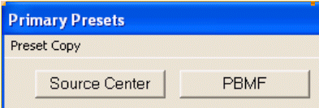
- select the closest preset to the targetted probe
- Beam OFF: Check that DPRIM3 X&Y maximizes the current
- Check that the same primary ion current is read with both Beam ON and Beam OFF.
- Switch the LPRIM4_A aperture to the suitable position : For the gaussian probes, 750 µm (#1) for the range [200µm, 50µm], 400µm (#2) for the range [50µm, 20µm], 200µm (#3) for the range [20µm, 2µm] and 100µm (#4) for the range [2µm, 0.2µm], and for the shaped beam mode, refer to the section § Shaped beam mode
- Tune LPRM3 for the required current intensity
- Tune the stigmator D5 S1 in combination with LPRIM4 to obtain the finest probe.
- With the gaussian mode and the proj1 mode, but not the proj2 mode, DS4 S1&S2 may also be used for improve the probe focusing.
- For the very small probes, it may be valuable to tune finely D4 X&Y byt setting it so that the spot does not shift when LPRIM4 is varied.
- Save the settings in a working preset.

Contents ↑

The Secondary ion optics (*)

Refer to the secondary ion optics user's guide/ secondary ion optics

The secondary ion detectors (*)
Refer to the secondary ion optics user's guide/ secondary ion detectors

The Depth profiling issue
Refer to the secondary ion optics user's guide/ The depth profiling issue

Controlling the ion optics from the computer
Refer to the secondary ion optics user's guide/ Controlling the ion optics from the computer

Contents ↑

